

**Educational Organisation Using ServiceNow**

**Team ID:** NM2025TMID20229

**Team Leader:** KARTHIK A

**Team Member 1:** ANAND KUMAR S **Team Member 2:** JOHN EDWIN R T**eam Member 3**: ABINESH A

**Category:** ServiceNow System Administrator

**Problem Statement:**

Educational institutions often face challenges in managing large volumes of student and teacher data, handling admissions, and monitoring academic progress. Manual processes are time- consuming, error-prone, and lack real-time visibility, making it difficult for administrators to make informed decisions.



# Objective:

he objective of the Educational Management System is to develop a centralized and automated platform on ServiceNow that streamlines administrative tasks within educational institutions.

# Skills Required:

TensorFlow

# Project Description:

## The Educational Management System is a comprehensive platform designed on ServiceNow to streamline administrative processes within educational institutions. It enables efficient management of student and teacher data, automates the admission process, and provides tools to track and monitor student academic progress.

**TASK INITIATION**

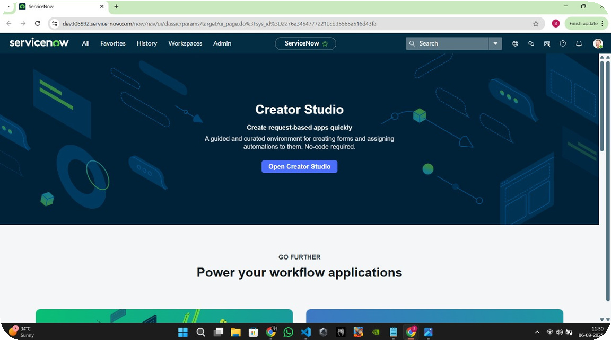

**Milestone 1 :** Setting up ServiceNow Instance

**Activity 1:** Create and Access Instance

1. **Open** [**ServiceNow Developer Site**](https://developer.servicenow.com/)**.**
2. **Sign up for a developer account and log in.**
3. **Navigate to Personal Developer Instance.**
4. **Click Request Instance and fill the required details.**
5. **Submit the request.**
6. **Once approved, check your email for instance details.**
7. **Log in using the provided credentials.**
8. **Verify that you can successfully access and navigate the instance.**

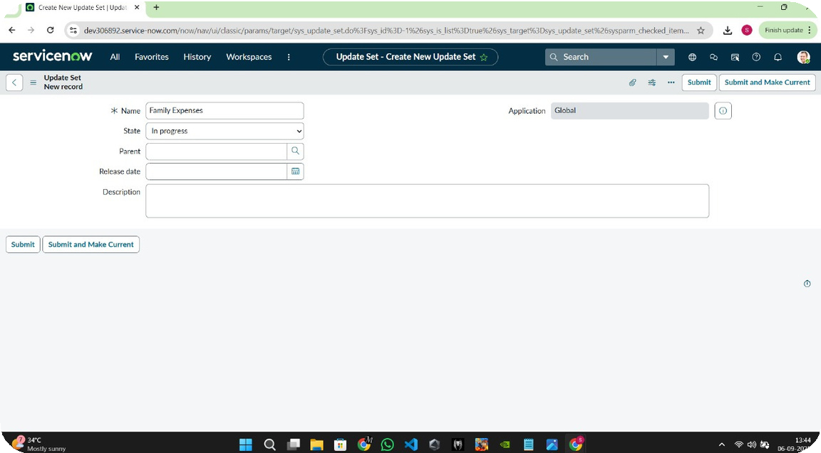

**Milestone 2 :** Create Local Update Set

**Activity 1:** Create Update Set

1. **Click on All >> Local Update Sets.**
2. **Click on New.**
3. **Enter the details: Name: Educational Organisation.**
4. **Click on Submit, then select Make Current to activate the update set.**

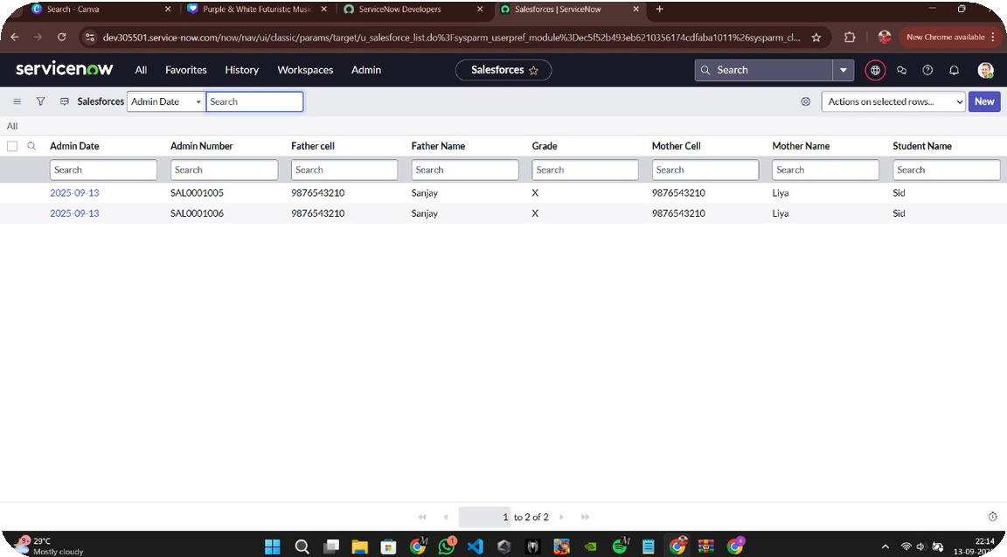

**Milestone 3:** Creation of New Update Set

**Activity 1:** Create Local Update Set

1. **Open ServiceNow.**
2. **Go to All >> in the filter, search for Local Update Set.**
3. **Click on New.**
4. **Enter the following details:**
5. **Name: Family Expenses**
6. **Click on Submit.**
7. **Select Make Current to activate the update set.**

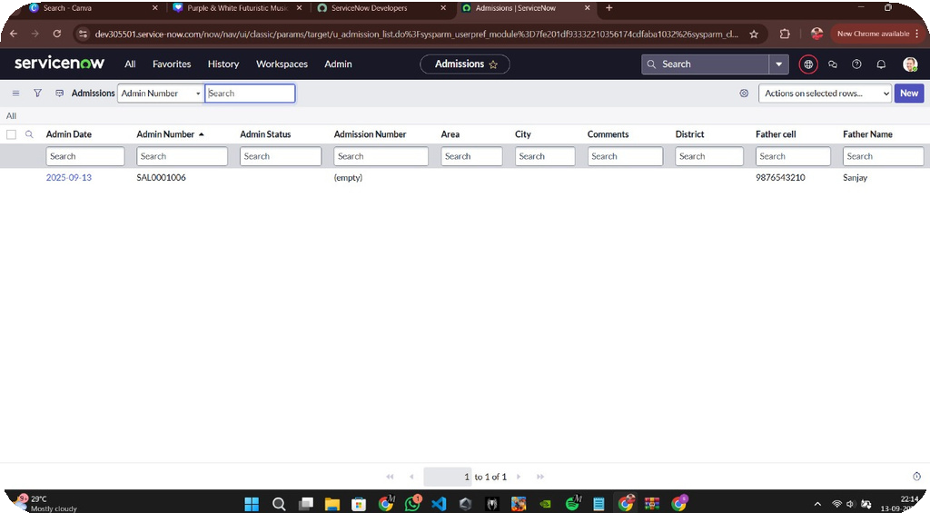

**Milestone 4:** Creation of Salesforce Table

**Activity 1:** Create New Table

1. **Go to All → Tables → New**
2. **Label: Salesforce (Name auto-generated)**
3. **Save the table**
4. **Add columns (set labels & types)**
5. **Set Admin Number → Display = True**
6. **Enable Extensible**
7. **Set Dynamic Default = Get Next Padded Number**
8. **For Grade column → add Choices (Label, Value, Sequence)**

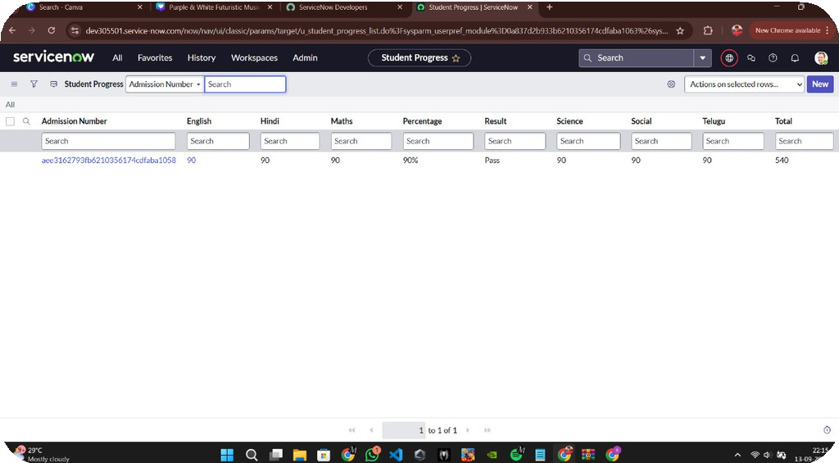

**Milestone 5 :**Creation of Salesforce Table

**Activity 1:**Table Setup

1. **Go to All → Tables → New**
2. **Label: Salesforce (Name auto-generated)**
3. **Save the table**
4. **Add columns (set Labels & Types)**
5. **Set Admin Number → Display = True**
6. **Enable Extensible**
7. **Set Dynamic Default = Get Next Padded Number**
8. **For Grade column → add Choices (Label, Value, Sequence)**

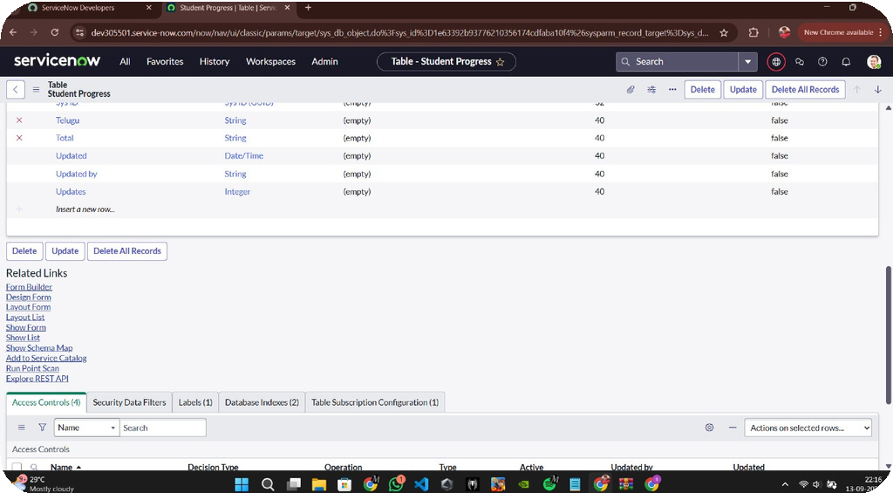

**Milestone 6 :** Creating Student Progress Table

**Activity 1:** Table Setup

1. **Create new table: Student Progress**
2. **Add module to menu → Salesforce**
3. **Add fields (Subjects, Marks, Grade, Remarks, etc.)**
4. **Set correct Labels, Types, Choices**
5. **Save the table**
6. **Verify module under Salesforce**
7. **Confirm fields are correctly configured**

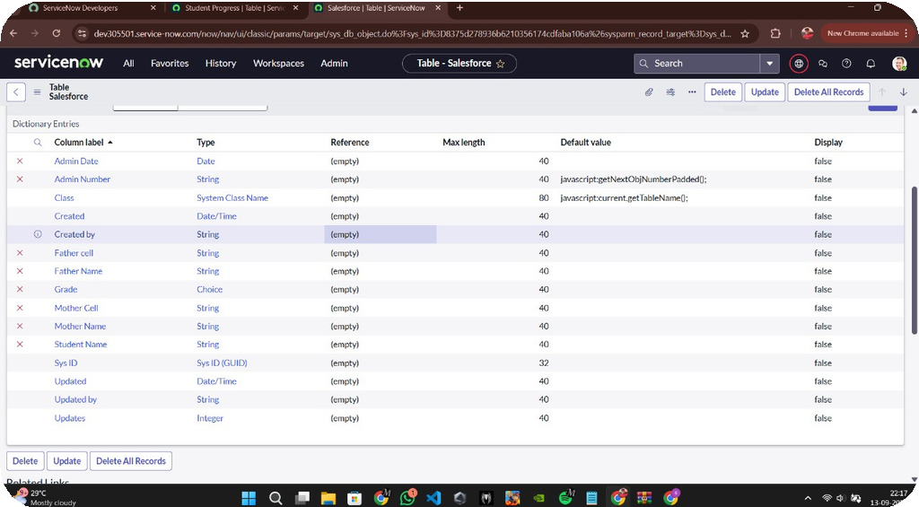

**Milestone 7:** Configuring Form for Student Progress Table

**Activity 1:** Form Layout Setup

1. **Open Student Progress Table page**
2. **Click on Layout Form**
3. **Add field Admission Number [+]**
4. **Arrange fields as required**
5. **Save the layout**

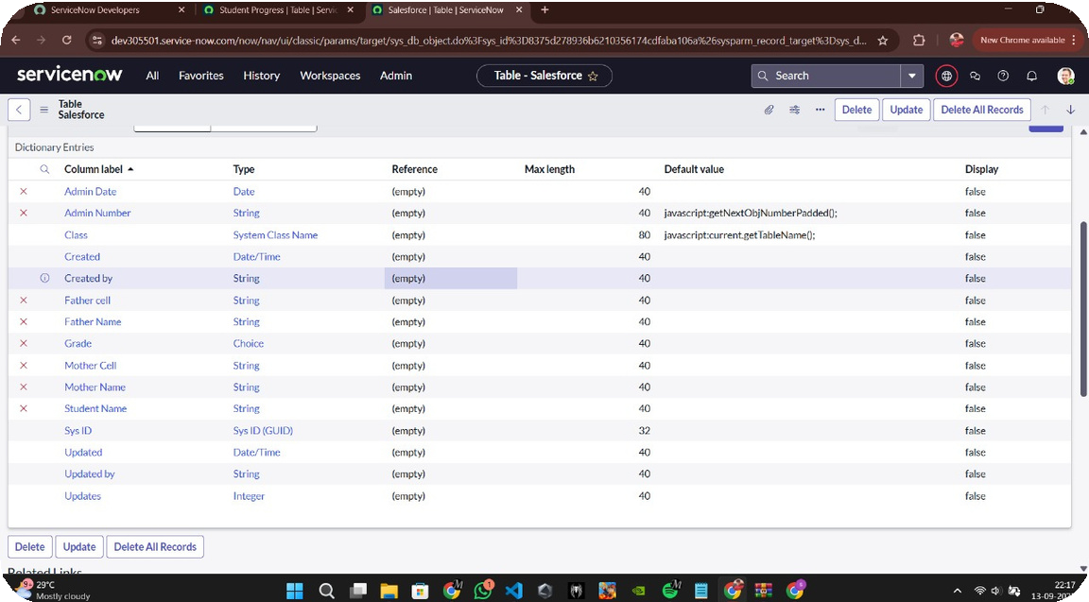

# Milestone 8: Creating Form Design for Salesforce Table

**Activity 1:** Configure Form Design.

* 1. **Go to All → System Definition → Tables**
  2. **Search and open Salesforce table**
  3. **Right-click on top toggle → Configure → Form Design**

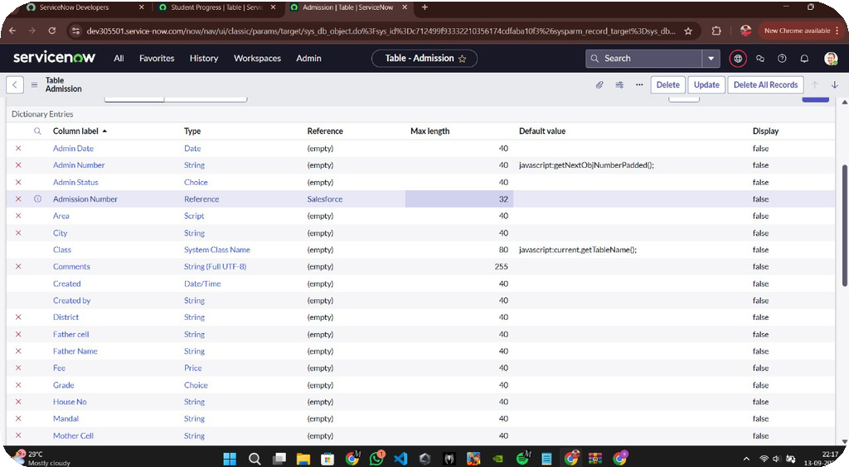

**Milestone 9 :** Creating Form Design for Admission Table

**Activity 1:** Configure Form Design

* + 1. **Follow same steps as in Activity 1 (Form Design setup).**
    2. **Configure the required fields for Admission Table.**
    3. **Save the form layout.**

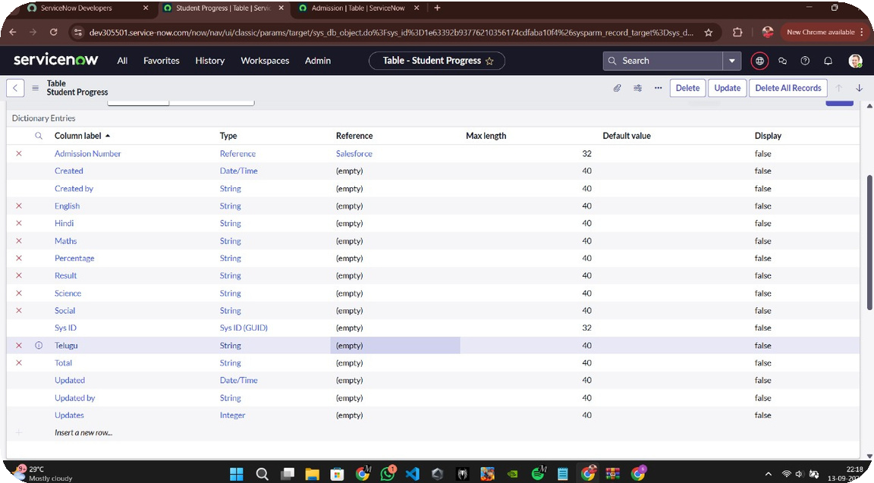

**Milestone 10 :** Creating Form Design for Student Progress Table

# Activity 1: Configure Form Design

* + - 1. **Follow the same steps as Activity 1 (Form Design setup).**
      2. **Configure the fields for Student Progress Table.**
      3. **Save the form layout.**

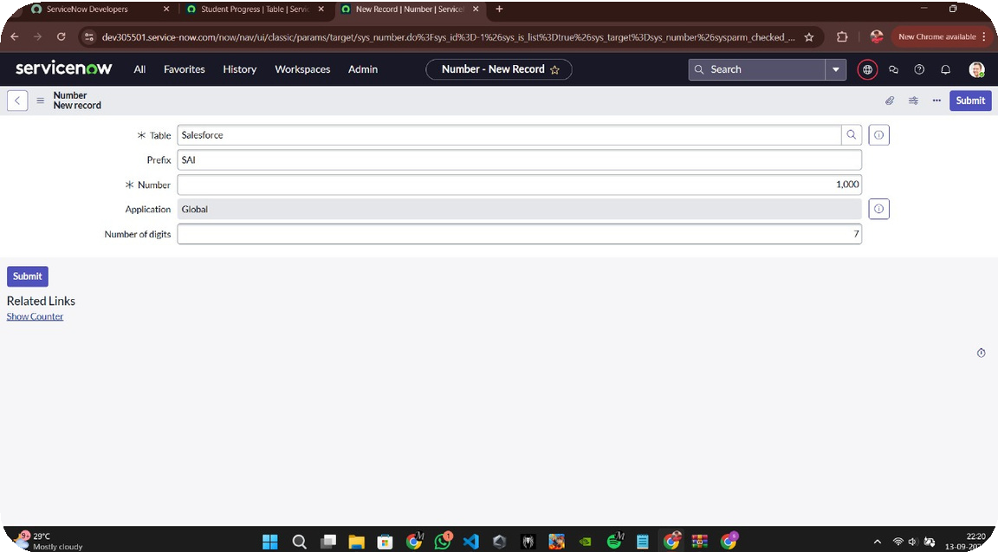

**Milestone 11:** Creating Number Maintenance for Admin Number

**Activity 1:** Configure Number Maintenance

1. **Go to All → Number Maintenance → New.**
2. **Fill in the required details.**
3. **Click Submit.**

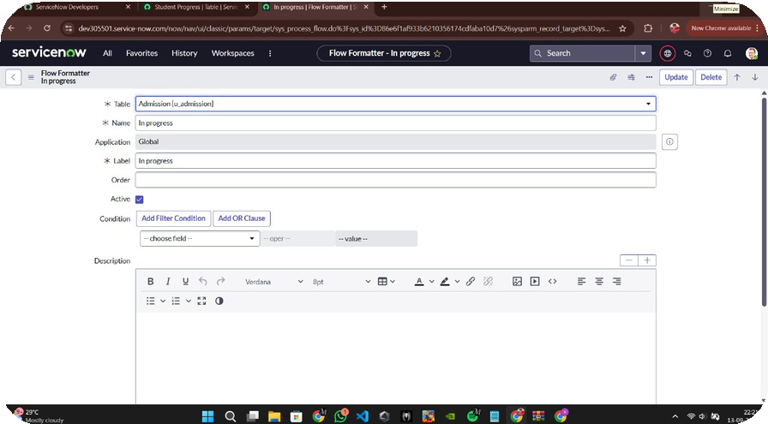

**Milestone 12 :** Creating Process Flow for Admission Table

**Activity 1:** Configure Admission Table Process Flow

1. **Go to All → Process Flow → New.**
2. **Fill in the required details.**
3. **Right-click on toggle → Save.**
4. **Replace Name & Label → Click Insert and Stay.**
5. **Add states in order:**
6. **New**
7. **InProgress**
8. **Joined**
9. **Rejected**
10. **Rejoined**
11. **Closed**
12. **Cancelled**

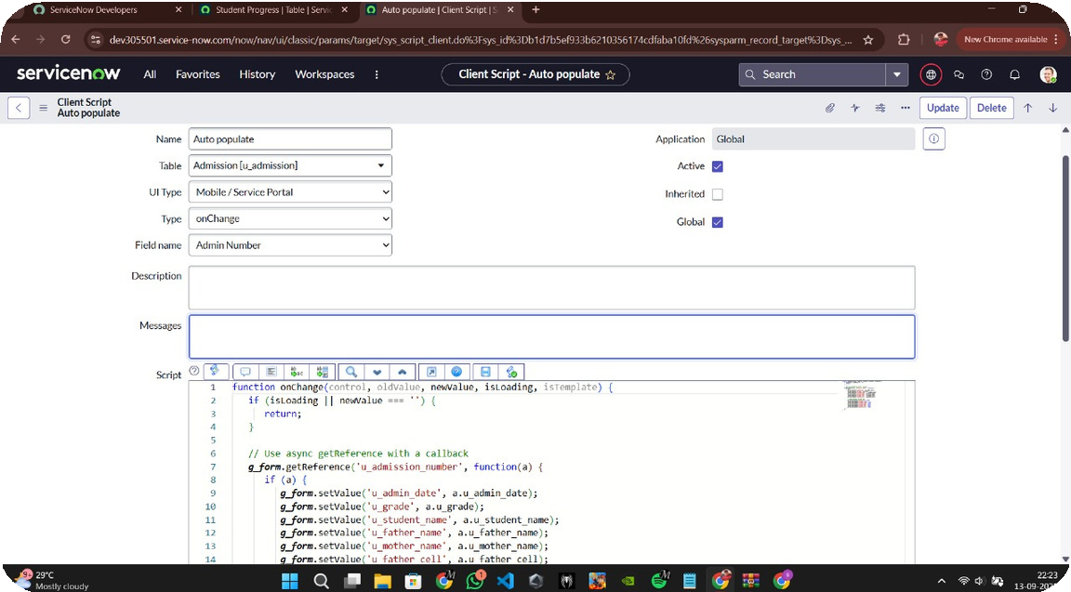

**Milestone 13 :** Creating Auto Populate Client Scripts for Admission Table

**Activity 1:** Configure Auto Populate Script

* 1. **Go to All → Client Scripts → New.**
  2. **Fill in the required details.**
  3. **Write the script:[in Portal Instruction]**
  4. **Enable Isolate Script.**
  5. **Save the script.**

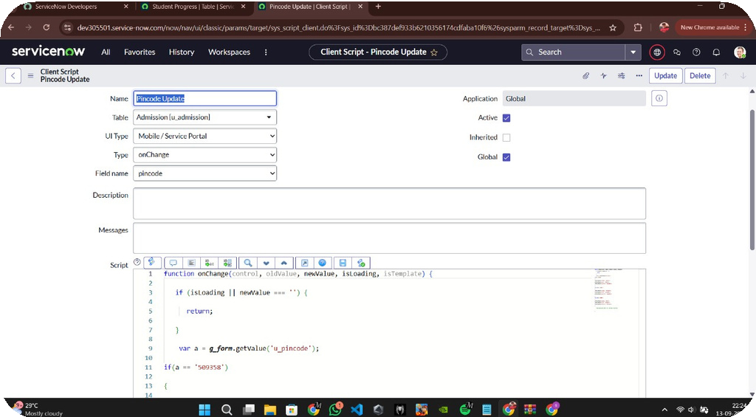

**Milestone 14 :** Creating “Pincode Update” Client Script for Admission Table

**Activity 1:** Create OnChange Client Script for Admission Table

1. **Navigate to Admission Table → Client Scripts → New and fill in required details (Name, Table, Type, Field).**
2. **Enable Isolate Script and Save.**
3. **Write the script to automatically update u_mandal, u_city, and u_district fields based on the entered u_pincode.**
4. **Include conditions for specific pincodes (e.g., 509358, 500081, 500079) to set corresponding mandal, city, and district values.**
5. **Test with different pincode inputs and validate that the fields update correctly.**

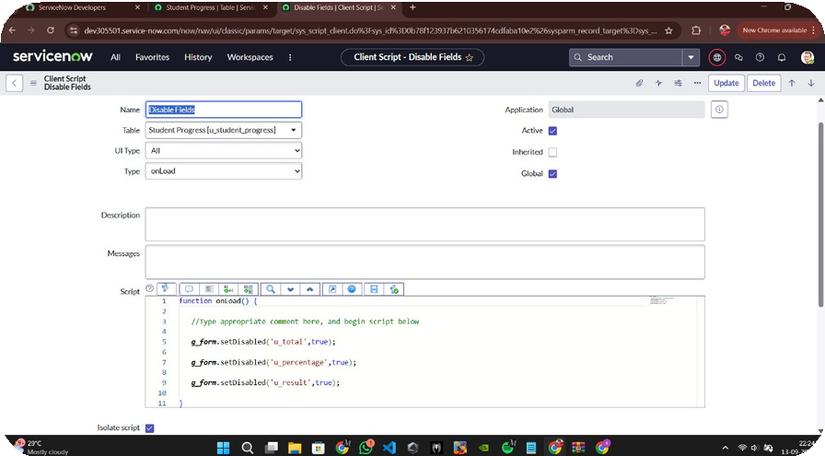

## **Milestone 15 :** Creating Disable Fields Client Scripts for Student Progress Table

**Activity 1:** Configure Disable Fields Script

* 1. **Go to All → Client Scripts → New.**
  2. **Fill in the required details.**
  3. **Write the script:**
  4. **function onLoad() {**
  5. **// Disable calculated fields on form load**
  6. **g_form.setDisabled('u_total', true);**
  7. **g_form.setDisabled('u_percentage', true);**
  8. **g_form.setDisabled('u_result', true);**

9. **}**

1. **Enable Isolate Script.**
2. **Save the script.**

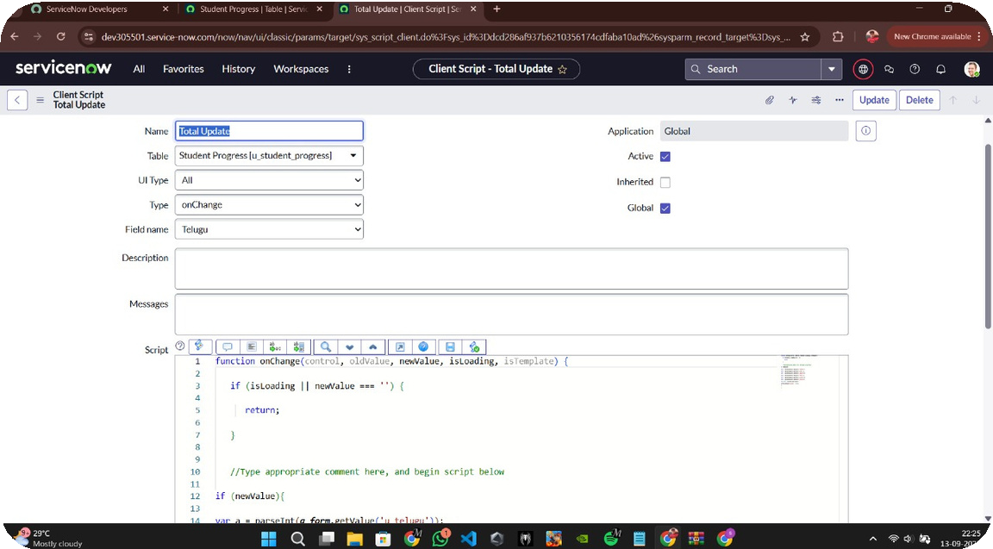

## **Milestone 16 :** Creating “Total Update” Client Scripts for Student Progress Table

**Activity 1:** Configure Total Update Script

1. **Go to All → Client Scripts → New.**
2. **Fill in the details (Table = Student Progress).**
3. **Write the script:[In Portal Instruction]**
4. **Enable Isolate Script.**
5. **Save the script.**

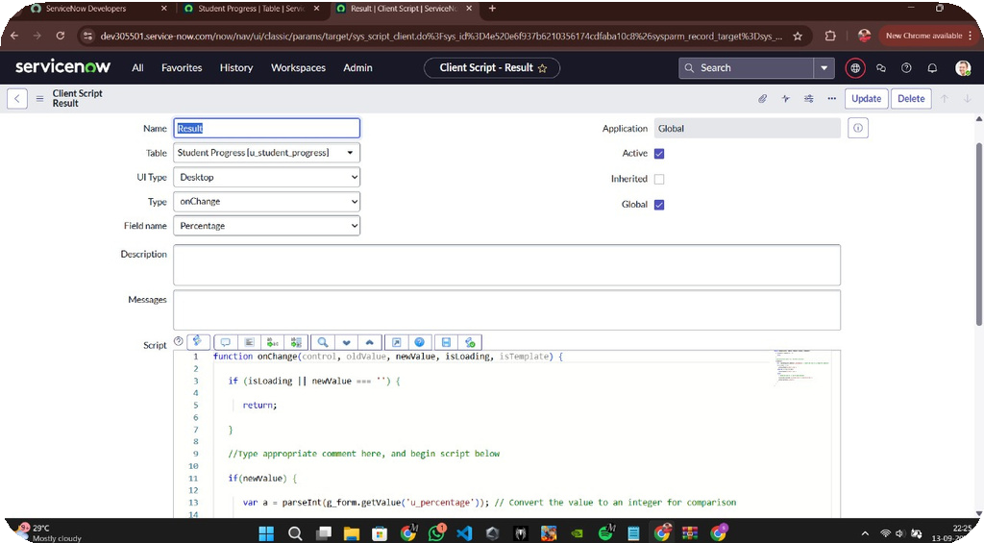

**Milestone 17 :** Creating “Result” Client Script for Student Progress Table

**Activity 1:** Create Client Script

1. **Navigate to Student Progress → Client Scripts → New and fill in required details (Name, Table, Type, Field).**
2. **Enable Isolate Script and Save.**
3. **Write the script to calculate u_result as Pass or Fail based on u_percentage.**
4. **Add error handling for invalid percentage values and clear u_result if out of range.**
5. **Test with different inputs and document script logic for future reference.**

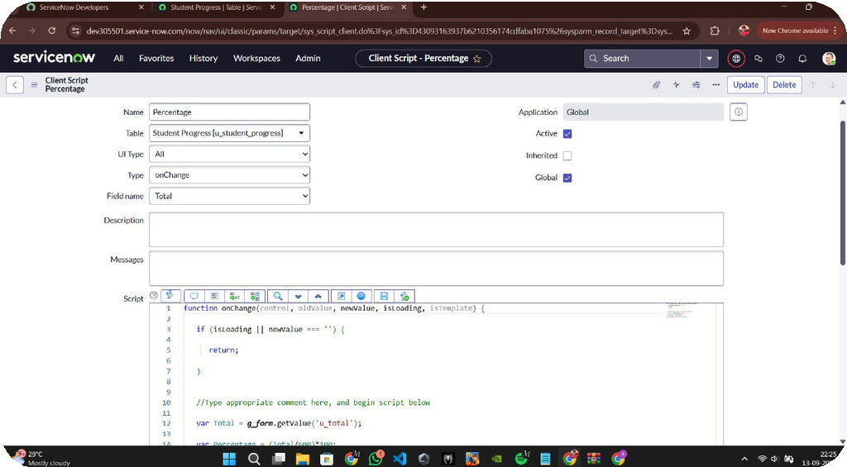

## **Milestone 18 :**Creating “Percentage” Client Scripts for Student Progress Table

**Activity 1:** Configure Percentage Script

1. **Go to All → Client Scripts → New.**
2. **Fill in the details (Table = Student Progress).**
3. **Add the script:**
4. **function onChange(control, oldValue, newValue, isLoading, isTemplate) {**
5. **if (isLoading || newValue === '') {return; }**
6. **var Percentage = (Total / 600) * 100;**
7. **g_form.setValue('u_percentage', Percentage + '%');}**
8. **Enable Isolate Script.**
9. **Save the script.**



# Conclusion:

The Educational Management System developed using ServiceNow offers a robust and efficient solution for managing the diverse administrative needs of educational institutions. By centralizing student and teacher information, automating admission procedures, and providing tools to monitor academic progress, the platform significantly reduces manual workload and enhances operational efficiency. The integration of advanced technologies like TensorFlow further enables predictive analytics and intelligent insights, supporting data- driven decision-making. Overall, this system not only streamlines administrative processes but also contributes to a more organized, transparent, and effective educational environment.